1. select SUBJ_ID from EXAM_MARKS where EXAM_DATE between '1999-1-10' and '1999-01-20';

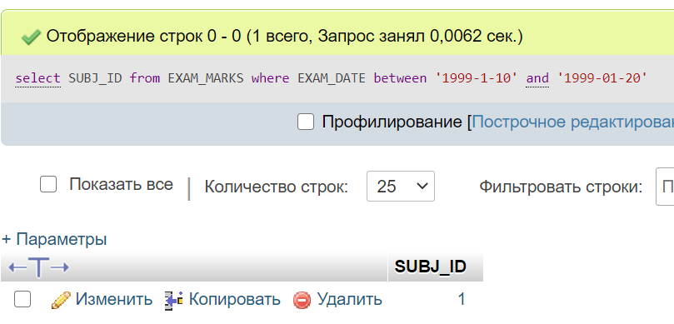

2. select *from exam_marks where STUDENT_ID in (2,4);

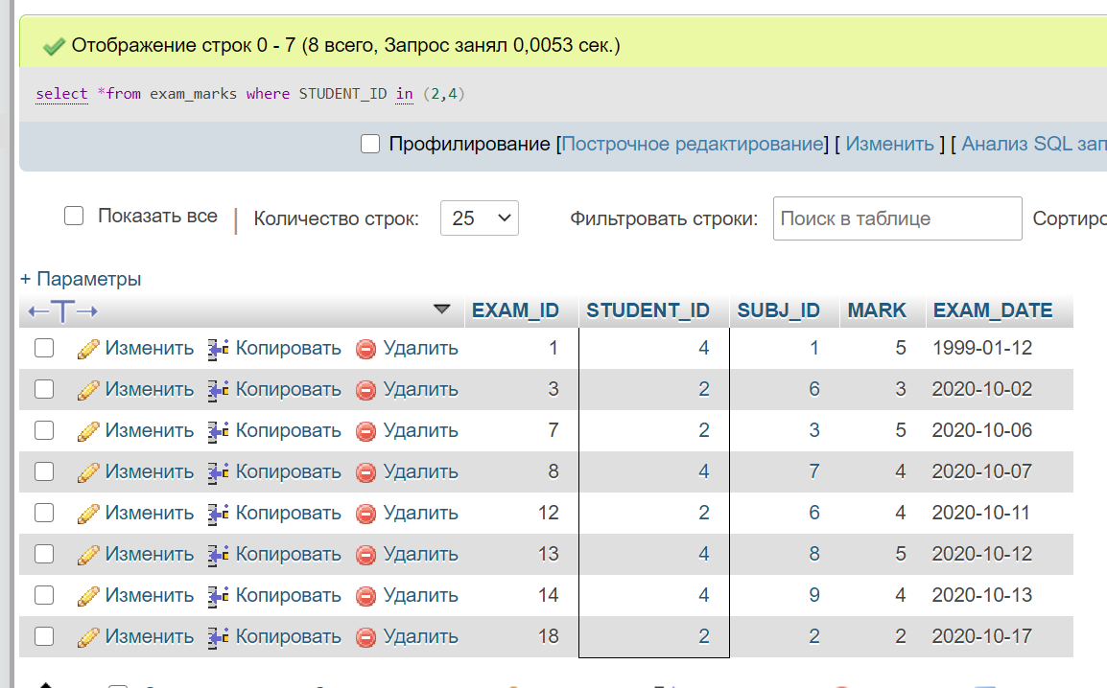

3. select subj_name from subject where subj_name like 'и%';

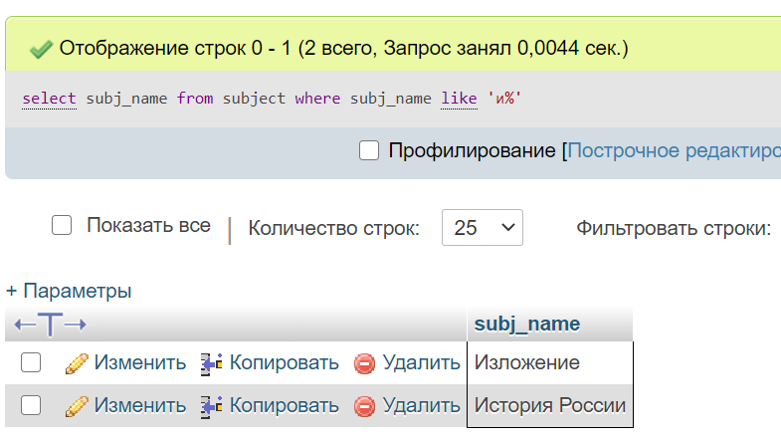

4. select *from student where surname like'с%' or surname like'в%';

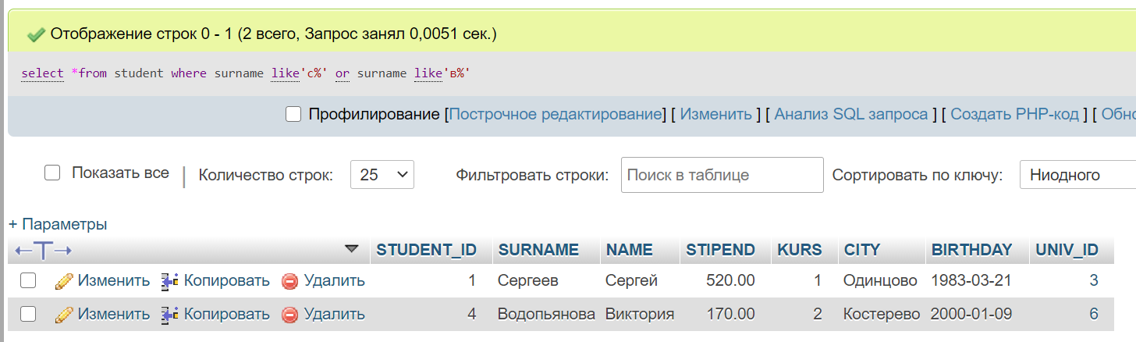

5. select *from exam_marks where mark is null;

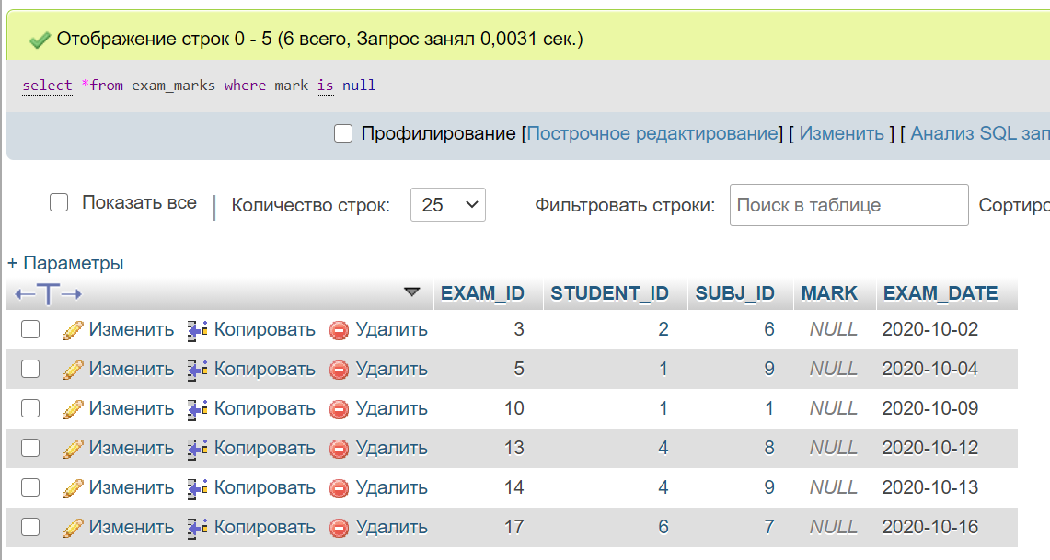

6. select *from exam_marks where mark is not null;

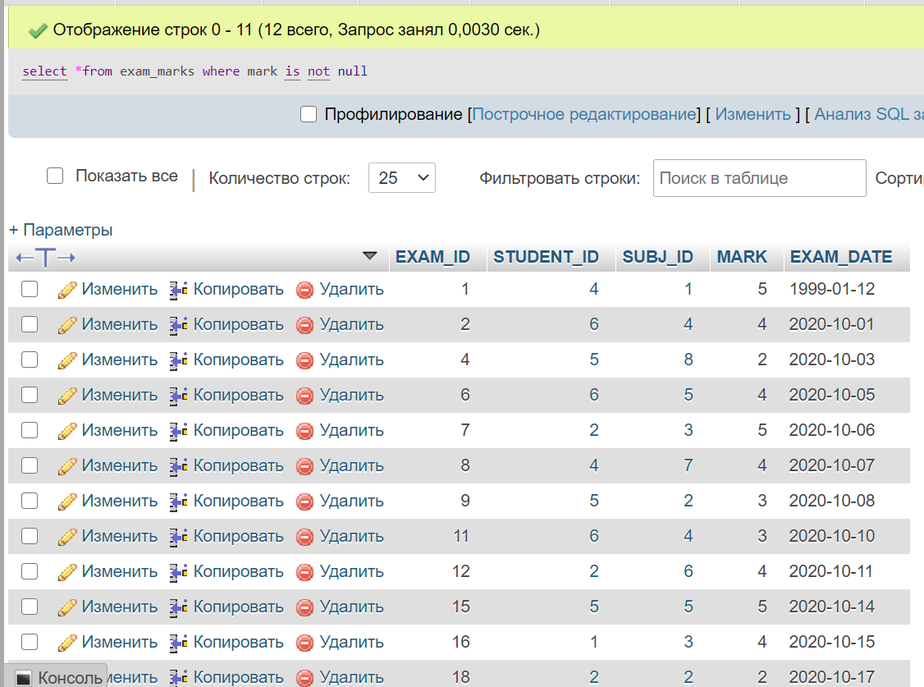

9. select count(*) from exam_marks where subj_id in (2) and mark>2;

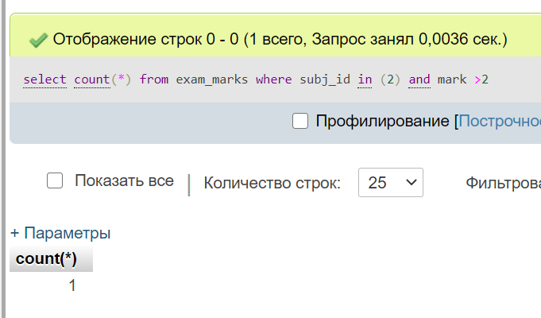

10. select count(distinct `SUBJ_ID`) from subject;

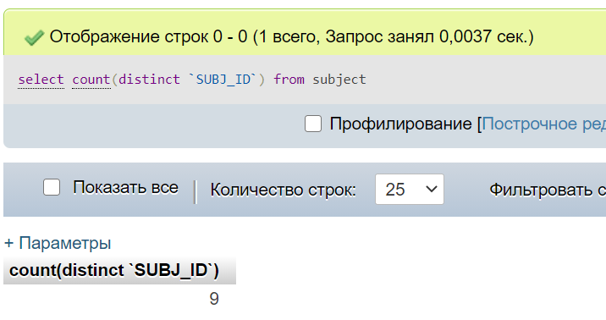

11.